**Sample Paper 2013**

## Class XII

**Subject: MULTIMEDIA AND WEB TECHNOLOGY**

* Please check that this question paper contains 5 printed pages.
* Code number given on the right hand side of the question paper should be written on the title page of the answer –book by the candidate.
* Please check that this question paper contains 7 questions.
* **Please write down the Serial number of the question before attempting it.**
* 15 minutes time has been allotted to read this question paper. The question paper will be distributed at 10.15 a.m. From 10.15 a.m. to 10.30 a.m., the student will read the question paper only and will not write any answer on the answer script during this period.

*Time allowed : 3 hours] [Maximum Marks :70*

1.

**a)** Define DBMS. Name any two software used to manage database. 1

**b)** Name the following: 1

i) A data type which can be used to automatically store monetary values with appropriate sign, commas and decimals.

ii) The view in which we can add, edit and view records in MS-Access.

**c)** Study the following data and answer the question given below: 4

Table : Bank

|  |  |  |  |
| --- | --- | --- | --- |
| **Acc_no** | **Name** | **Dt_opening** | **Dt_closing** |
| 1012 | Dr. Purohit | 03/12/2006 | Not closed |
| 5053 | Major Karan | 07/05/1989 | 01/01/2007 |
| 3210 | Er. Ashwin | 02/02/2002 | Not closed |

Table : Locker

|  |  |  |  |
| --- | --- | --- | --- |
| **Acc_no** | **Locker_no** | **Type** | **Amount** |
| 1012 | 2222 | Single | 12450000 |
| 1012 | 5465 | joint | 12324552 |
| 1012 | 707 | joint | 32456546 |

(i) Suggest data types that should be used for each of the fields in the table Locker.

(ii)Name the field which can be act as the foreign key for the table Locker.

(iii) What type of relationship exist between the table bank and the table Locker.

**d)** Master Adarsh is planning to gift a digital album of ‘MODEL SAARC CONFERENCE 2012 ’ to his teacher on her farewell. All the images have lots of colour shading and are all static images. Which of the following formats are best suited for this purpose: 2

(i) GIF

(ii) JPEG

(iii) AVI

justify your choice

**e)** What is the full form of GIF ? 1

**f)** Differentiate between JPEG and MIDI file formats. 1

1. **Questions given below are based on FLASH :**
2. What is the extension of following file format 1
   * 1. Window Projector ii. Real player
3. What do you understand by timeline? 1
4. What do you understand by Panels ? 1
5. Explain the usage of the following tools available in Flash 5. 2
   * 1. Playhead ii. Onion-skinning feature
6. What do you mean by publishing a flash movie ?Name different formats in which flash movie can be published . 2

f) Observe the figure given bellow and do as directed : 3

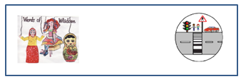

* The image on the left hand side shows the position and size of the image for frame1.
* The image on the right hand side shows the position and size of the image for frame 40.

Write the procedure and property settings for animating the above scenario.

1. **Questions given below are based on HTML :**

**a)** Name any two implicit tag that can be used in place of <B> AND <I> tags . 1

**b**) What is the use of # sign in intra file linking in HTML? 1

**c**) Write the HTML code to generate a Web Page in the format given below : 8

Consider the following while writing the HTML code

1*.* Background color of the page should be “Magenta”, text color should be “Maroon” .

2. Title of the page is “Real women,global vision”.

3. Text color of main heading on the page should be “Blue”.

4. Font face of text in the page should be “Arial”.

5. Picture used in the page is the file “roleofwomen.jpg”.

6. Use the concept of list inside table .

7. Pages linked to :

*FAQ to faq.html*

*Bbookings to booking.php*

*Links to link.html*

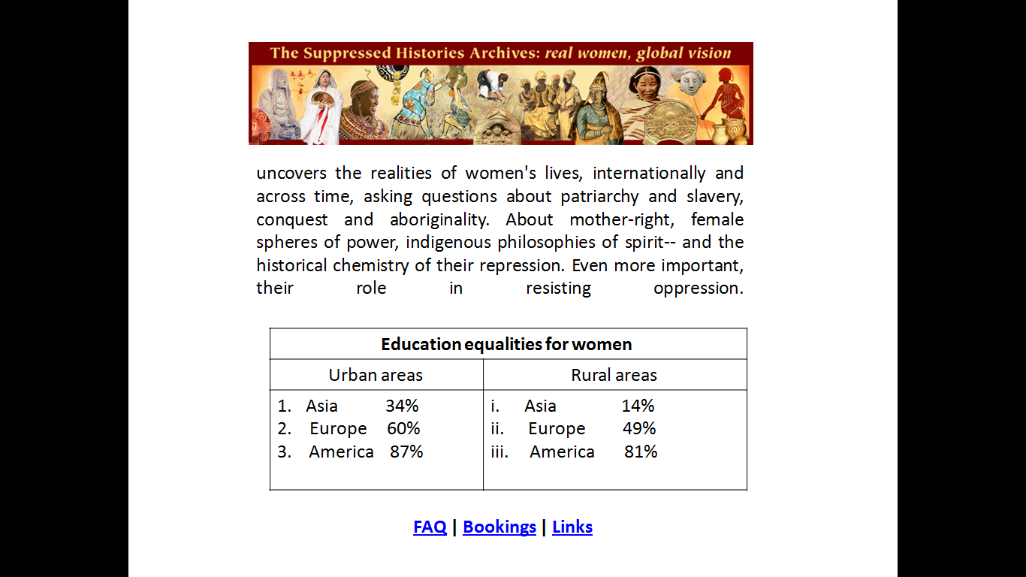

**4. Question given below are based on ASP :**

1. Name the web server required to execute ASP on Windows Operating system. 1
2. What do you understand by ASP object? Name different ASP objects. 1

**c)** Identify the following: 2

(i) The collection used to retrieve the values of form elements sent using the GET method.

(ii) The alternate command for <% response.write(”HELLO”) %>

**d)** Use the following script to answer the questions that follow: 2

<%

DIM X

X = 10

Sub result()

SID

Y = 20

SID

END SUB

SUB SID

X=X+6

Y=Y+5

END SUB

%>

(i) What is the scope of variable X and Y in the above script?

(ii) What is the value of X and Y before the subroutine SID ends?

**e)** Observe the following script: 1

<SCRIPT LANGUAGE = “VBSCRIPT” RUNAT=”SERVER”>

DIM A, B

A=0;B=1;I=1

Do while I <= 5

C= A*B

RESPONSE.WRITE C

A=B

B=C

LOOP

</SCRIPT>

Whenever this script is executed, the programmer find that it runs continuous infinite time. Identify the error and write the corrected code.

**f)** Find output 3

1. Response.write(ucase(mid(“we become leaders and innovators by performing leading and innovating actions.”,2,13))
2. Response.write(instr(“My India My Pride...” , “ia”)
3. Response.write( Right (“Different Shades of Patriotism” , 4)

**5. Question given below are based on ASP :**

**a)** Observe the program segment given below carefully and fill the blanks marked as Line 1 and Line 2 using methods of the RecordSet object for performing the required task.3

<%

DIM objConn, strConn, objRS

SET objConn = Server. CreateObject(“ADODB.Connection”)

strConn = “DSN=exam”

objConn. Open strConn

SET objRS = Server.CreateObject(“ADODB.RecordSet”)

objRS.Open “Student”, objConn, 2, 2

objRS.MoveLast ‘Move the cursor to the end of file

______________ ‘Line 1 to Add a new blank record

objRS(“AdmNo”) = Request.Form(“AdmNo”)

objRS(“Name”) = Request.Form(“Name”)

______________ ‘Line 2 to save the record in the database

objRS.Close

objConn.Close

SET objRS = Nothing

SET objConn = Nothing

%>

1. Predict the output of the following ASP code. 2

<html>

<body>

<% dim a,b

a=1

b=10

do while a<30

response.write(a*b)

a=a+10

b=b-5

loop%>

1. Convert the following coding in to for....next 2

<html>

<body>

<%

s=array(10,30,50,70,90,110)

max=ubound(s)

i=1

do while i<5

s(I) = 10*s(I)

response.write (s(I) & “<br>”)

i=i+2

loop %>

</body>

</html>

1. Write the ASP code that will read the text file called multi.txt , and display only the line that start with “W”. 3

**6. Question given below are based on VBScript :**

**a)** Define the term event. Name the events to be used in the following situations: 2

(i) To perform an action when a button is clicked.

(ii) To perform an action as soon as the contents of a text box change.

**b)** Give the output for the following script code: 2

<Script Language="VBScript">

B=10

C=11

D=12

For A=1 to 12 step 5

C=A+B+C+D

Document.Write(C)

B=B-5

D=D+5

Next

</Script>

**c)** Find the errors and rewrite the correct code : 2

<Script Language=”VB Script”>

Dim A , B ,c , d

A = 1

B = 10

DoWhile A < 5

Document.read(A+B)

A + 1 =A

B = B – 2

Document.write(A+B+C+D)

Next loop

</Script>

**d)** Write the HTML code for creating the form given below and also write the embedded VBScript code for the click event of the submit button. 4 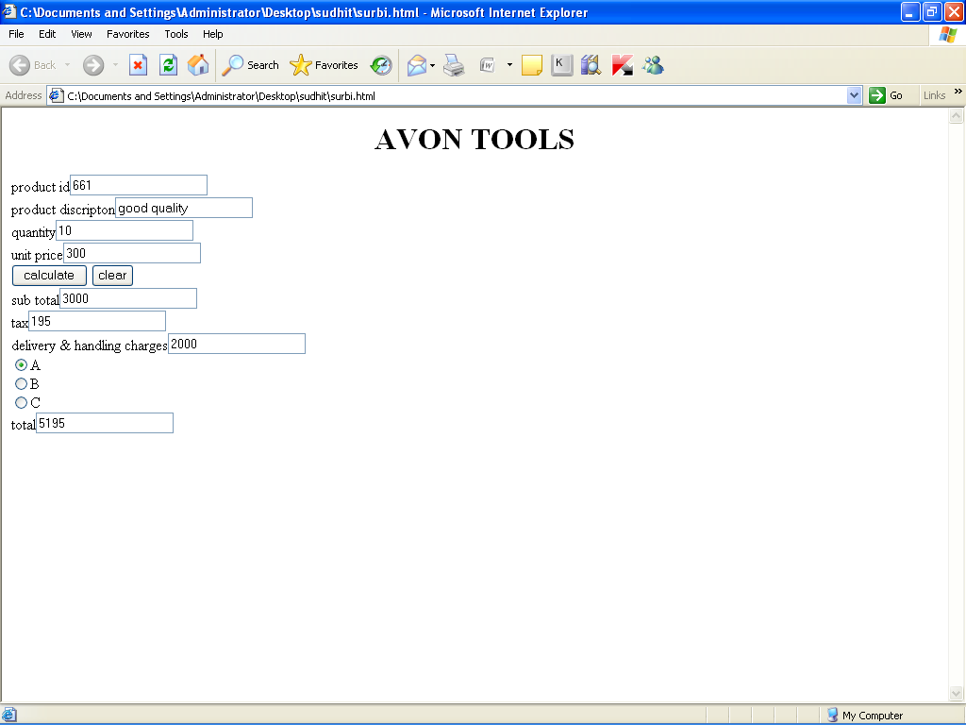

**7. Question given below are based on Network and OSS :**

1. Write a short note on Intranet . 1
2. Define Gateway. 1
3. Write short notes on SMTP. 1
4. Write short notes on the following Channel Allocations (Wireless/Mobile Comunication) 1
5. WLL
6. What do you mean by Open Source Software ? What are the conditions required for the Open Sources software ? 1
7. Define UNICODE . 1
8. ProActor School of acting in Mumbai is setting up the network between its different wings. There are four wings named as SENIOR(S), JUNIOR(J),ADMIN(A), and HOSTEL(H). 4

***The distances between the different wings are given below :***

Between A and S 100 mts.



Between A and J 200 mts.

Between A and H 400 mts.

Between S and J 300 mts:

Between S and H 100 mts.

Between J and H 450 mts.

Number of computers in each wings is as given below:

***Wing No. of Computers***

WING A 10

WING S 200

WING J 100

WING H 50

Answer the following questions based on the above given information:

1. Suggest the most suitable topology for connecting these wings.
2. Suggest the most suitable place to house the server. Justify your choice.
3. Where and why should repeaters be used?
4. The second branch of the school situated in a hilly region is to be linked with its headquarters in Mumbai. Suggest the most economical way to connect it. The organization is ready to compromise on the speed of connectivity.

*****